DIGITAL LOGIC DESIGN (CS-101)
By
NAMAL YASEEN
BSCS-2025-044
TO
MA’AM RIMLA
BACHELOR OF SCIENCE
IN
COMPUTER SCIENCE

DEPARTMENT OF COMPUTER SCIENCE
FAISALABAD INSTITUTE OF SCIENCE AND TECHNOLOGY (FIST)
(2025-2029)

LAB 1:

Main Purpose:
The main objective of this lab is to understand the functionality and performance of various Integrated Circuit (IC) logic gates by analyzing their truth tables and verifying them using NI Multisim software.

Components Required:
- Relevant Digital Logic Gate ICs:
- 7408 (AND)
- 7432 (OR)
- 7404 (NOT)
- 7400 (NAND)
- 7402 (NOR)
- 7486 (XOR)
- Connecting Wires / Virtual breadboard
- NI Multisim Software (Version 13.0 or above)
Theoretical Background:
Introduction to Integrated Circuits (ICs):
An Integrated Circuit (IC) is a tiny semiconductor chip that combines multiple electronic components (like transistors, resistors, and diodes) into one single package to perform specific logical or arithmetic functions.
Examples:
- Microprocessors,
- Memory chips
- Digital logic units.

Classification of Logic Gates:
Basic logic gates are the fundamental building blocks of complex digital electronic circuits. These gates perform basic Boolean operations based on binary inputs (0 or 1) and produce a single binary output according to their defined functionality.
Multisim Circuit Simulation:
AND GATE:
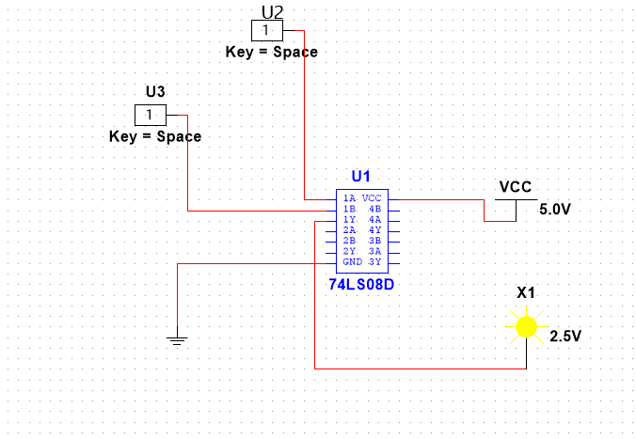
OR GATE:
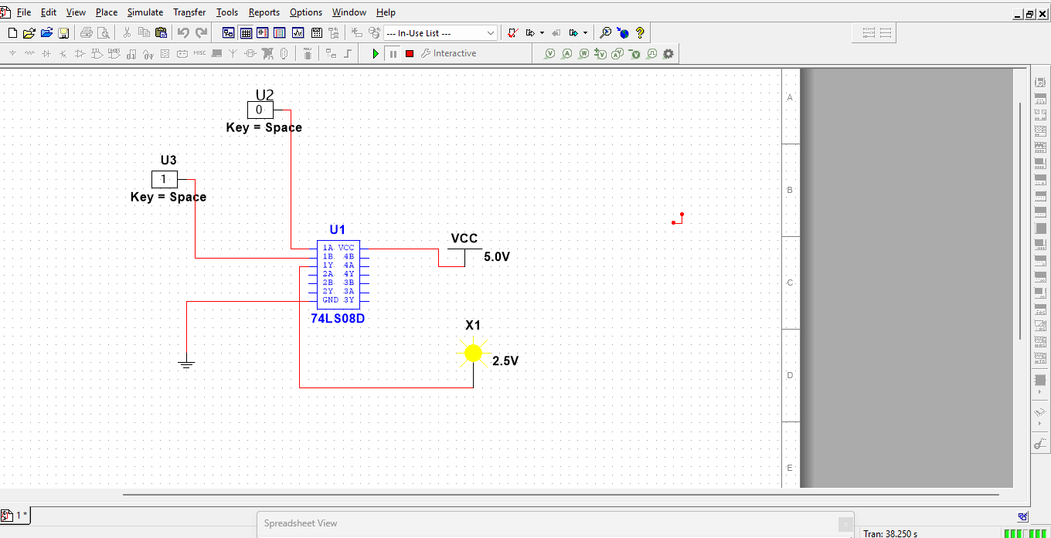

NOT GATE:

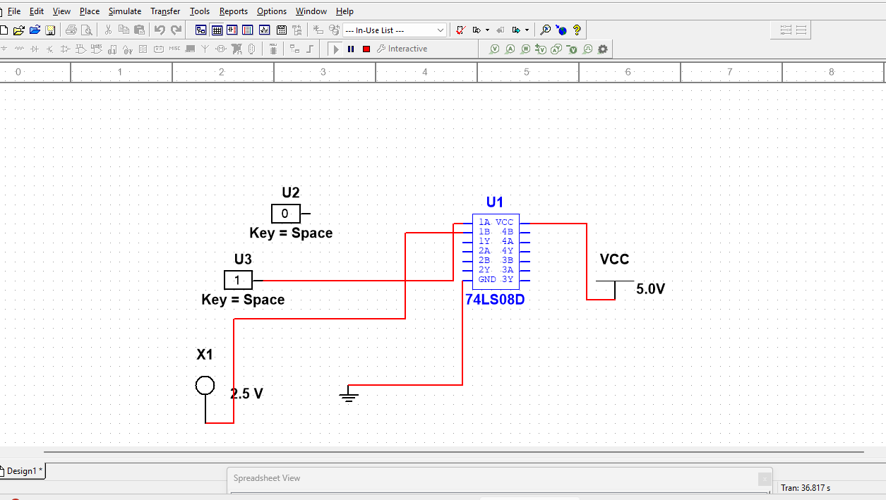

NAND GATE:
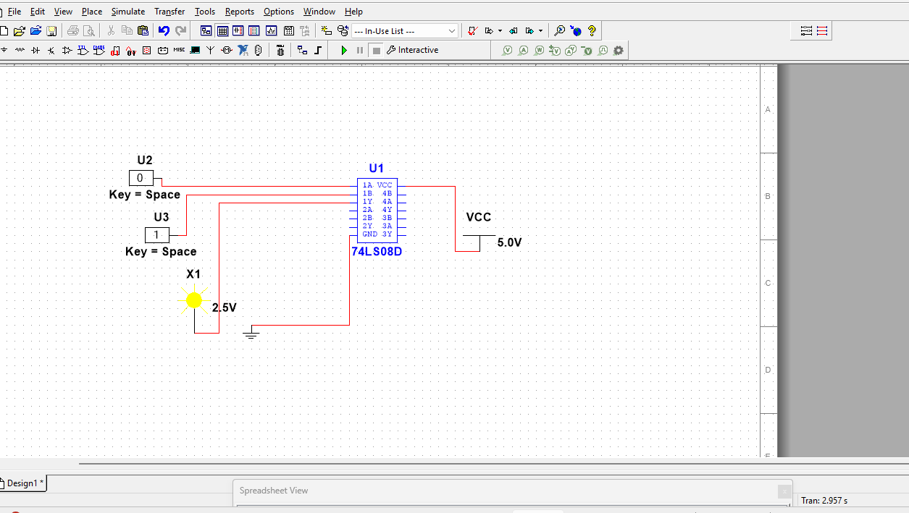

NOR GATE:
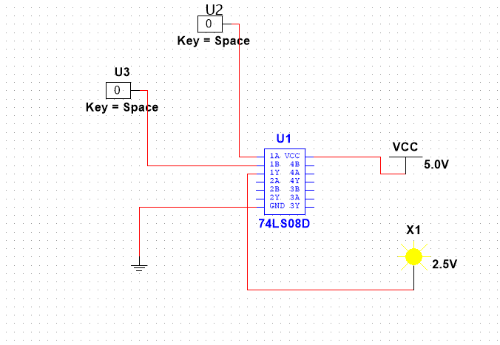
XOR GATE:
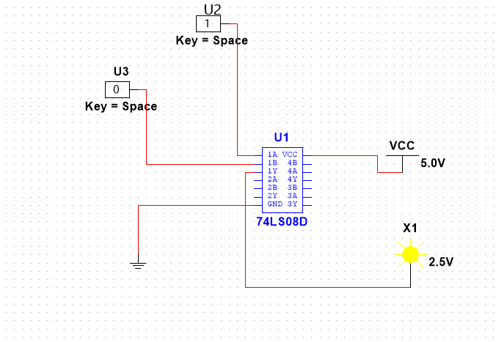

LAB 2:

IMPLEMENTATION OF A BOOLEAN:
FUNCTION AND VERIFICATION OF DEMORGAN'S LAW:
TASK 1:
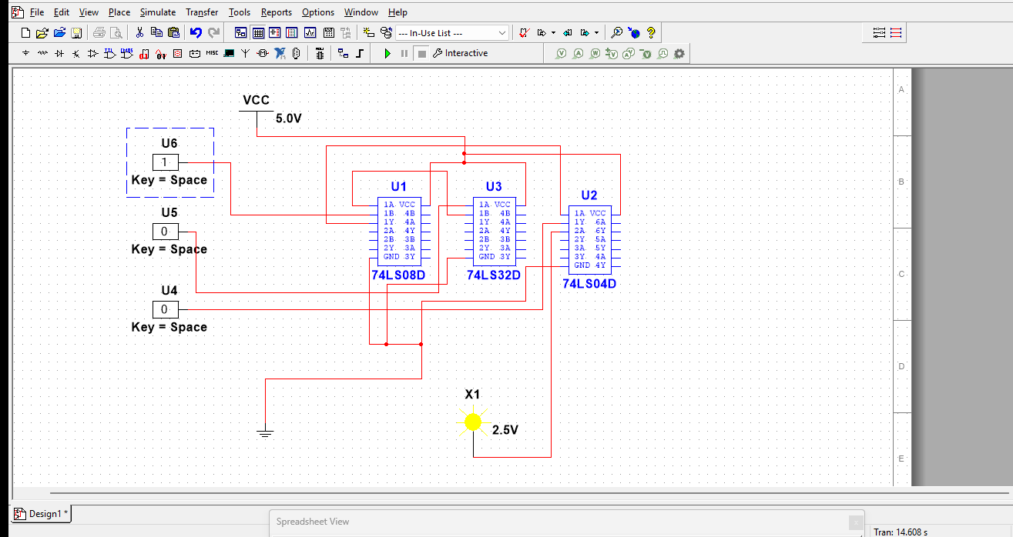

TASK 2:
X|+Y’Z
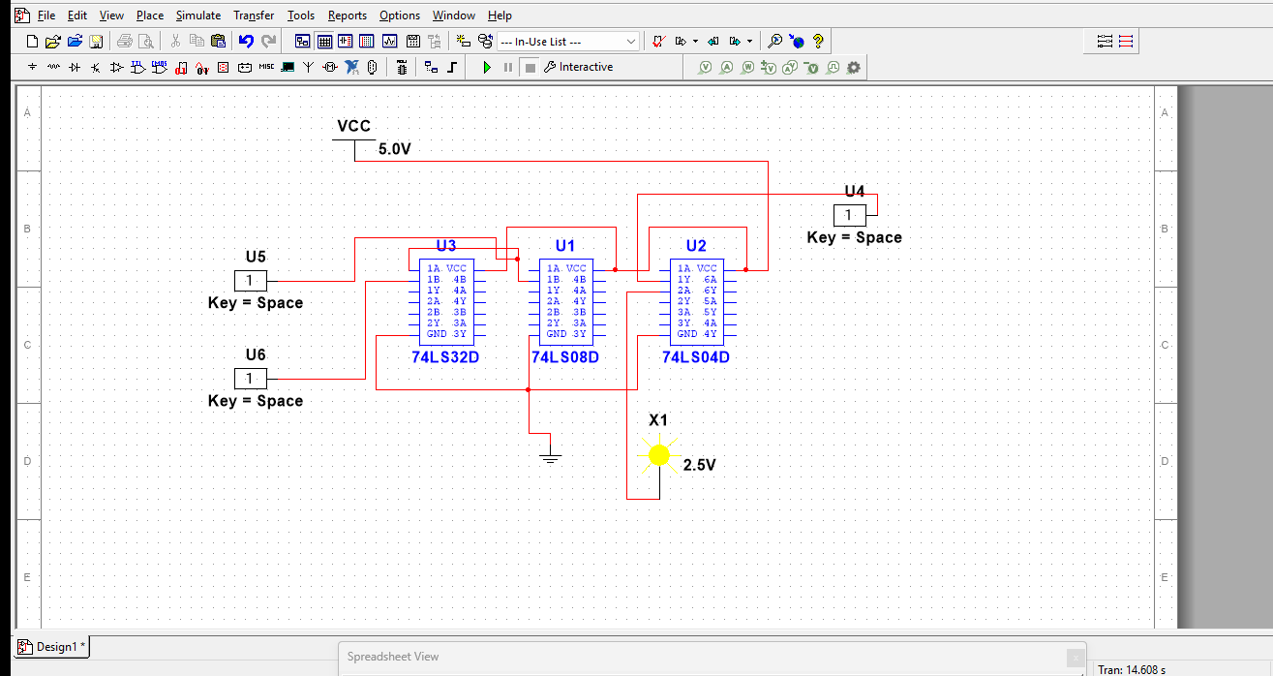
X’Y’Z +X’YZ +XY’:
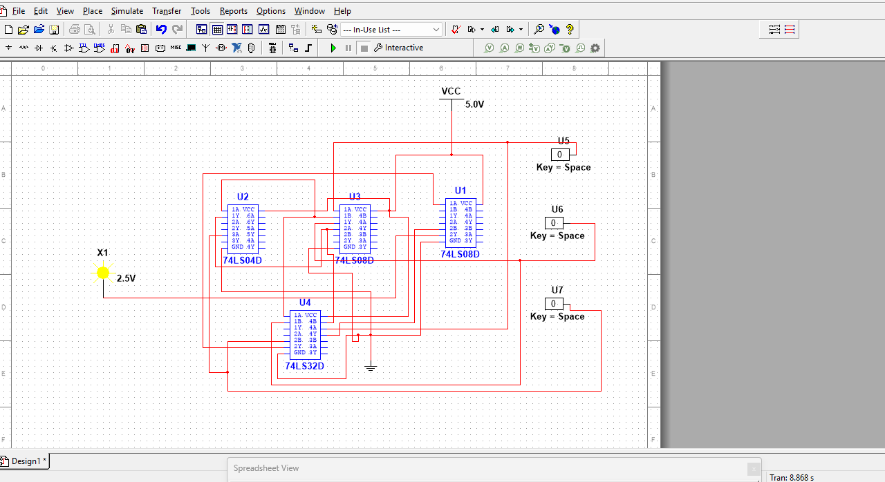

1ST LAW:
(X+Y)=X’.Y’:
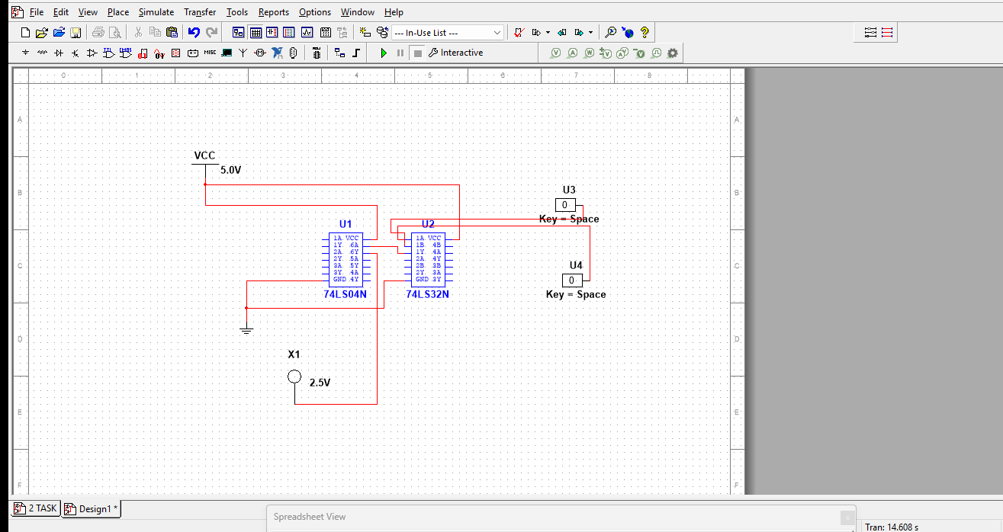
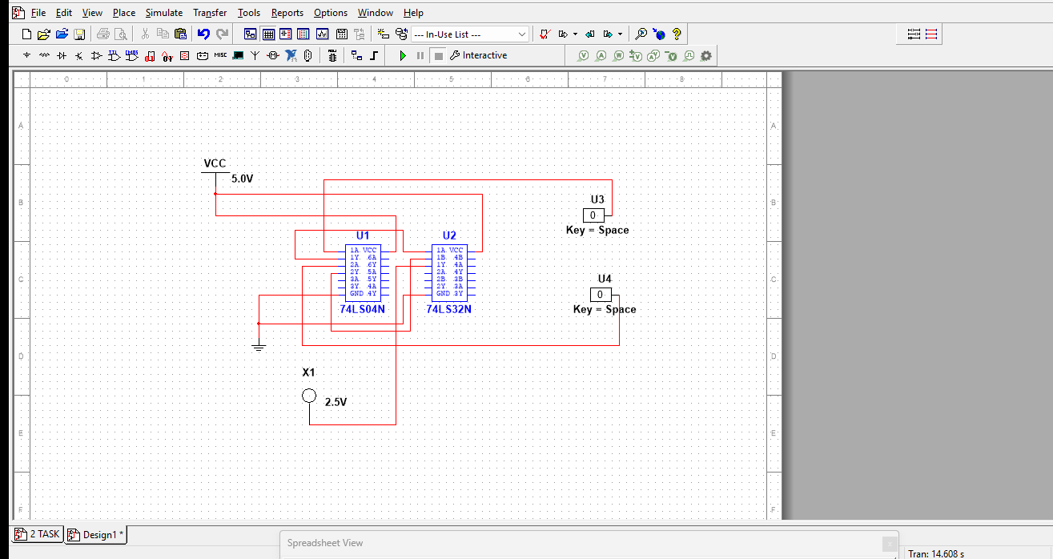

2ND LAW:
(X.Y)=X’+Y’
